China Customs Enforcement of Intellectual Property Rights (IPR) in 2009

General Administration of Customs of the People’s Republic of China (GACC)

**Contents**

**Introduction**

**I. Overview of Customs IPR Enforcement in 2009**

**II. Particulars of Infringing Goods Detained by Customs in 2009**

**III. Key Measures for Customs IPR Protection**

**IV. Key Work of Customs IPR Protection in 2010**

**Appendix: Statistics of China Customs IPR Enforcement in 2009**

**Introduction**

In 2009, China Customs firmly implemented the policies made by the State against international financial crisis to focus on the optimization of Customs' supervision and service, introduced and carried out “Ten Measures of Customs for Promoting Economic Development” including strengthening the protection of intellectual property rights (IPR). In the field of IPR enforcement, in addition to the continuous strict monitoring on commodities infringing the IPR at import and export links, the Customs had also imposed centralized enforcement in post and express delivery sections where infringements are more concentrated. Customs protection of the IPR has not only effectively maintained the import and export order in fair competition, but also promoted Chinese enterprises’ industrial restructuring, growth mode transformation and enhancement of the international competitiveness of products by technology progress and self-dependent innovation so as to realize economic recovery of China.

**I. Overview of Customs IPR Enforcement in 2009**

In 2009, in order to provide intellectual property rights (IPR) protection, China Customs suspended the release of 67,000 consignments of imported and exported goods in total, with nearly 66,000 consignments detained for suspected infringement upon the IPR.[1]Compared with 2008, the consignments of goods whose release were suspended by Customs increased by 4.1 times in 2009; and the consignments of detained infringing goods[2] increased by nearly 5 times (see Figure 1).

**Figure 1 Schematic Diagram for Consignments of Goods Suspended to be Released and Detained by Customs in 2009**

Consignments of Goods Suspended to be Released

Consignments of Goods Detained



In 2009, China Customs detained 280 million pieces of infringing commodities in total with a value up to RMB 450 million. Compared with 2008, the infringing commodities detained by Customs in 2009 reduced by approximately 57%, equivalent to approximately 360 million pieces; but the value of commodities increased by approximately 53%, equivalent to nearly RMB 160 million (see Figure 2).

**Figure 2 Schematic Diagram for Quantity and Value of Infringing Goods Detained by Customs in 2009**

Value

Quantity of Goods Suspected of Infringement



There are mainly 2 reasons resulting in sharp rise in consignments and commodity value while dramatic decline in quantity of infringing goods detained by Customs in 2009:

**1. The consignments of infringing goods detained by Customs rose sharply owning to the “special action for IPR protection in post and express delivery sections”.**

From June 1 to December 31, 2009, 7-month “special action for IPR protection in post and express delivery sections” was carried out under the organization of the General Administration of Customs of the P. R. China (GACC). The consignments and commodity value of infringing goods seized by all port Customs during the special action respectively increased by 7 and 4 times compared with the corresponding period of 2008.

**2. The rise in consignments and commodity value and decline in quantity of infringing goods detained by Customs in 2009 were mainly caused by the change in commodity structure thereof.**

Among the infringing goods detained by Customs in 2009, tobaccos declined sharply in quantity. As cigarette is large in quantity but low in value[3], the reduction of seized cigarette in quantity caused the decline in quantity of the infringing commodities detained by Customs in 2009. On the contrary, commodities including medicine, clothing, cosmetics and care products, and auto parts with relatively high value detained by Customs in 2009 increased sharply.

**II. Particulars of Infringing Goods Detained by Customs in 2009**

Considering from the infringing goods seized by Customs, the import and export of infringing goods in 2009 are characterized as follows:

**(I) Exported goods still in overwhelming majority**

In 2009, the quantity of infringing goods seized at the export link by China Customs is 280 million pieces with a value of RMB 450 million, respectively accounting for 99.9% and 99% of all infringing goods.

Active and initiative enforcement at the export link is still a major characteristic of China Customs IPR protection work in 2009. It should be noted that, according to the Agreement on Trade-Related Aspects of Intellectual Property Rights (i.e. TRIPS Agreement)[4], contracting parties are not obliged to provide IPR protection at the export link. Nevertheless, in order to maintain international trade order in fair competition and the health and safety of global consumers, the Chinese Government has authorized by legislation China Customs to provide IPR protection at both import and export links. Initiative implementation of IPR protection at the export link is not only a need of the economic development of China but also a great contribution to global IPR protection undertaking beyond the range of due international obligations.

**(II) Goods infringing the exclusive right to use trademark in majority**

In 2009, infringing goods retained by China Customs were mainly related to exclusive right to use trademark, copyrights, copyright-associated rights, patent rights, Olympic symbols, World Expo symbols, and other different rights, but the goods infringing the exclusive right to use trademark detained by Customs were in overwhelming majority. Among the infringing goods detained by Customs in 2009, 65,000 consignments were related to exclusive right to use trademark[5].The Customs detained nearly 280 million pieces of commodities infringing trademark right, with a value of nearly RMB 430 million, respectively accounting for 99% of the quantity and 94% of the value of all infringing commodities.

**(III) Sharp decline of cigarettes and significant increase of others**

Among the infringing goods detained by China Customs in 2009, the top 10 commodities ranked by quantity of single commodity were tobacco, cosmetics and care products, hardware tools, clothing, medicine, automobile and motorcycle and accessories, communication equipment, shoes, bags and watches; the top 10 ranked by value were storage media, communication equipment, medical equipment, clothing, jewelry, tobacco, hardware tools, bags and leatherware, cosmetics and care products, and watches.

Among the infringing goods detained by China Customs in 2009, there was significant increase in both quantity and amount of the seized commodities including medicine, hardware tools, clothing, cosmetics and care products, shoes and auto accessories. But the quantity of infringing cigarettes detained in 2009 declined sharply to 181 million pieces, reduced by 68%, equivalent to 381 million pieces compared to the 560 million pieces in 2008.The proportion in the quantity of all commodities detained in that year also declined from 87% in 2008 to 65% in 2009.

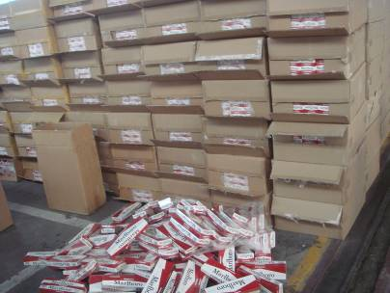

Counterfeit Cigarettes for Export Detained by Shenzhen Customs in 2009

**(IV) Consignments of posted and express-delivered goods are in large proportion while the quantity of shipping commodities still tops**

In 2009, the infringing goods detained in post and express delivery sections by China Customs were respectively in 45,000 and 18,000 consignments, accounting for 68% and 28% respectively of all detained consignments, and increased by nearly 5 times and 12 times compared with 2008. Nevertheless, the quantity of infringing commodities detained in sea transportation section still dominated. In 2009, Customs detained 1,490 consignments of infringing goods in sea transportation section; although it accounted for only 2% of the total detained consignments, the quantity of detained commodities was up to 270 million pieces, taking up approximately 98% of the total detailed commodities. These are all consistent with the characteristics of international transportation of post goods and shipping goods.[6]

**(V) Import and export are concentrated in several ports**

In 2009, there were 34 customs districts nationwide that seized infringing goods at the import and export links. Among them, six Customs including Shanghai, Guangzhou, Shenzhen, Hangzhou, Beijing and Harbin Customs seized 62,000 consignments of infringing goods in total, accounting for approximately 94% of the total consignments seized by Customs nationwide (see Figure 3). Shanghai, Guangzhou, Beijing and Harbin are ports relatively concentrated with post and express delivery import and export of China, and the significant increase in consignments of infringing goods seized at the four Customs in 2009 was related to the sharp rise in seizing times of infringing goods in post and express delivery sections during “special action for IPR protection in post and express delivery sections”.

Considering from the quantity of detained infringing goods, Customs with heavy workload of supervision on shipping goods remain the major force of IPR enforcement. In 2009, six Customs (Shenzhen, Ningbo, Huangpu, Hangzhou, Shanghai and Xiamen) intercepted nearly 280 million pieces of infringing commodities, accounting for approximately 99% of total detained infringing goods by Customs nationwide (see Figure 4). Among them, Shenzhen Customs seized the most infringing commodities with a proportion of 72% of the total, which is mainly attributable to the large proportion of cigarettes in the infringing commodities seized by Shenzhen Customs.

**Figure 3 Schematic Diagram for Consignments of Infringing Goods Detained by Customs of Ports in 2009**

Guangzhou  
20%

Shanghai

Harbin

Others

Beijing

Hangzhou

Shenzhen

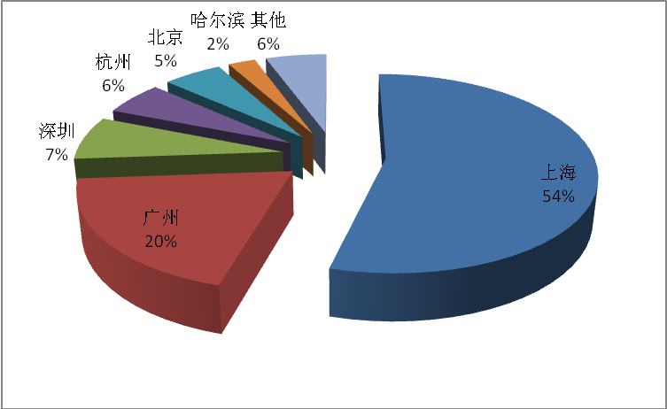

**Figure 4 Schematic Diagram for Quantity of Infringing Goods Detained by Customs of Ports in 2009**

Hangzhou Shanghai Xiamen Others

Ningbo

Huangpu

Shenzhen

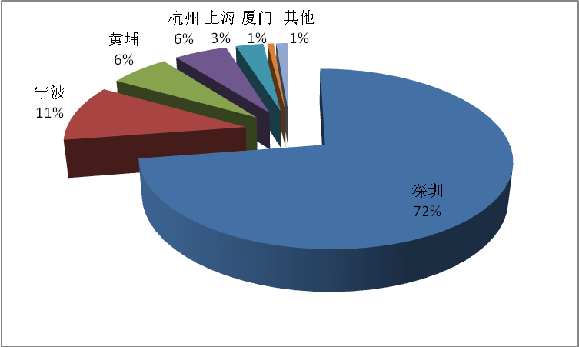

**(VI) The IPR involved are most related to American and European right holders and Chinese IPR holders also benefit a lot**

In 2009, the IPR holders that had received protection from China Customs were from 34 countries or regions. There were 11,462 items of IPR protected by Customs.[7]IPR holders involved were mostly from U.S., France, Italy, Japan, Germany, Finland, Switzerland, China[8], Luxembourg, Britain and the Netherlands (see Figure 7). Seen from the infringing commodities related to IPR, infringements upon IPR from Britain, Switzerland, China, U.S. and France ranked among the top five (see Figure 8). In particular, although the quantity of commodities involving the IPR of Chinese enterprises only accounted for 7% and ranked third after Britain and Switzerland, actually, Chinese enterprises obtained more extensive benefit from the IPR enforcement by Customs, as the commodities infringing the IPR of Britain and Switzerland enterprises seized by Customs in 2009 were dominated by cigarettes (including 78 million pieces of cigarettes infringing the IPR of Britain enterprises and 99 million infringing that of Switzerland, respectively accounting for 28% and 35% of the total detained infringing goods by Customs in 2009) while the commodities infringing the IPR of Chinese enterprises covered various industries including production, life, stationery, food, medicine, vehicle and accessories.

**Figure 7 Schematic Diagram for Sources of Protected IPR**

Others

Germany

Switzerland

Netherlands

U.S.  
37%

Finland

Japan

China

Luxembourg

Britain

Italy

France  
15%

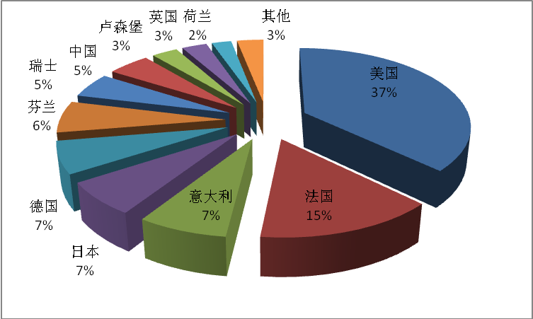

**Figure 8 Schematic Diagram for Quantity of IPR-related Commodities**

Britain

39%

Others

China

U.S.

France

Switzerland

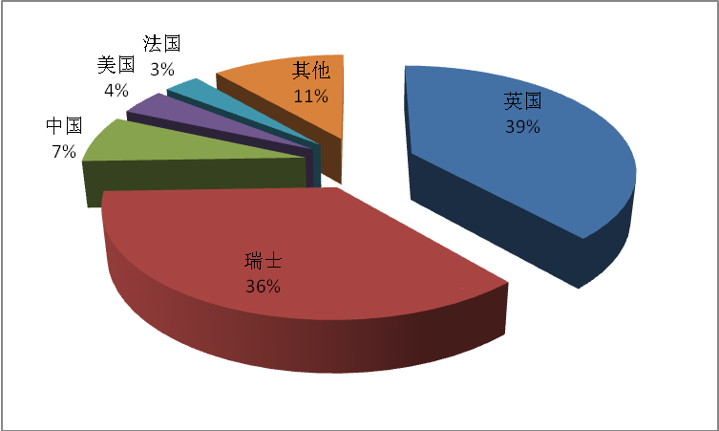

**III. Measures for China Customs IPR Protection in 2009**

As everyone knows, the Customs is the national entry and exit supervision authority, and the international transportation of infringing commodities could be effectively restrained through border enforcement. Therefore, high expectations are given to the IPR protection function of the Customs. However, with the continuous expanding of international trade, the quantity of goods transported internationally increases rapidly, and the import and export supervision tasks of the Customs of each country become heavier. Strictly supervising and effectively investigating the illegal exports and imports (including the goods infringing the IPR) while ensuring the smooth clearance of the exports and imports is a serious challenge that China Customs faced in 2009. However, China Customs overcame difficulties such as heavy enforcement tasks and limited enforcement resources and achieved the goals of “facilitating lawful trade” and “fighting against infringing trade".

China Customs took a series of IPR protection measures in 2009.

**(I) Give full play to the supervision function of the Customs and actively investigate and punish the infringements and unlawful acts**

According to the stipulations of TRIPS Agreement, the contracting parties’ obligations are limited to only authorizing the Customs to suspend the free flow of infringing goods at the request of the IPR holder, and the contracting parties are not obligated to actively take IPR protection measures ex officio.[9]However, China Customs actively carry out the enforcement actions to protect the IPR according to the authorization under the Chinese law. In 2009, the infringing goods detained by China Customs ex officio (including the detaining according to the IPR registration and the initiative detaining through the luggage and postal sections) were about 66,000 consignments, accounting for 99.8% of the total detained consignments; there were 280 million pieces of detained infringing goods which accounted for 98.5% of the total infringing goods while the commodity value of such detained infringing goods were RMB 430 million which accounted for 94.3% of the total commodity value. China Customs actively carried out the IPR enforcement actions and played a positive role in effectively restraining the global infringing trade.

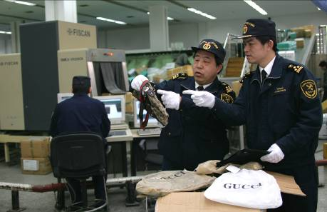

Shanghai Customs actively investigate and seize the infringing exported and imported postal parcels by using inspection equipment

**(II) Organizing and conducting “special action for IPR protection in post and express delivery sections”**

As the post and express delivery sections have become an important channel for the cross-border circulation of infringing goods, from June 1 to December 31, 2009, the GACC organized and conducted a “special action for IPR protection in post and express delivery sections” nationwide. During the “special action”, all the Customs of China ports centralized the enforcement resources and carried out the key monitoring towards the imported and exported parcels and express items and properly increased the inspection proportion according to the requirements of the GACC and got wonderful achievements. During the “special action”, 38,000 consignments of infringing goods were seized and 2.61 million consignments of infringing goods were retained, and the value involved amounted to RMB 62,000. The number of consignments, goods quantity and value of the infringing postal items and express items seized by the Customs during the “special action” increased by 738%, 28% and 402% respectively compared with the corresponding period of 2008.

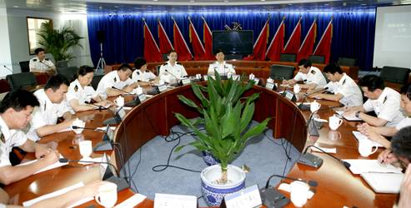

Beijing Customs plan and arrange the work to be carried out related to the special action

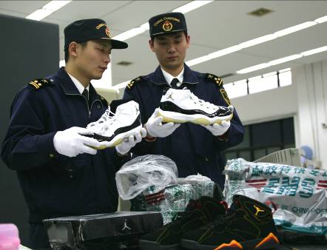

Shanghai Customs reinforce the supervision over the postal articles during the “special action”



The fake iPhone seized by Guangzhou Customs during the “special action”

**(III) Continue to reinforce the protection of proprietary IPR of domestic enterprises**

Reinforcing the protection of proprietary IPR of domestic enterprises is the key for the Customs’ enforcement work in 2009. In 2009, 565 consignments of goods infringing the proprietary IPR of domestic enterprises were retained by the Customs in China while there were more than 20 million pieces of seized infringing goods with a value of nearly RMB 49 million.

Many of the infringed proprietary IPR belong to the competitive products of China to be exported. For example:

Guangdong Zhongshan Lanju Daily Chemical Industrial Co., Ltd. is the world’s largest specialized manufacturing enterprise of domestic hygiene insecticidal products, the products of which have high share of market on African market. However, in recent years, the quantity of infringing "Lanju" mosquito-repellent incense on African market is more than 10 times that of the total export volume of the company, causing a loss on sale of more than RMB 200 million to the company. In order to protect and support the proprietary brand, Xiamen Customs initiatively invited Lanju Company to accept the training of identifying the infringing products in April 2009 and seized 430,000 boxes of infringing mosquito-repellent incense exported to Africa in May 2009 with a value of RMB 270,000.

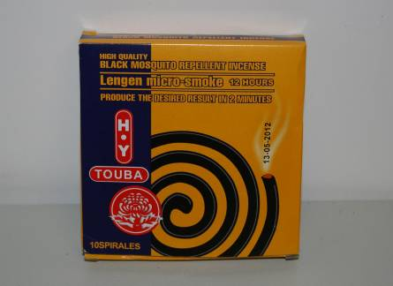

Infringing mosquito-repellent incense seized by Xiamen Customs

The “Tri-circle” padlock manufactured by Shandong Yantai Tri-circle Lock Industry Group Co., Ltd. has a high reputation on the international market, and is also infringed frequently. To preserve the international popularity and image of “Tri-circle” trademark, Customs of each port in China regards “Tri-circle” as the key point when protecting the domestic proprietary brand. In 2009, 18 consignments of exported padlocks amounting to 1.45 million padlocks infringing “Tri-circle” trademark were seized by the Customs in China.

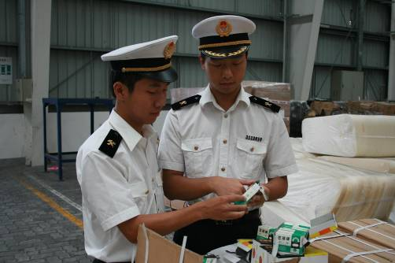

In 2009, Ningbo Customs seized 1.4 million padlocks to be exported infringing “Tri-circle” trademark

The Customs’ protection of proprietary IPR greatly stimulates the enthusiasm of domestic enterprises to participate in the Customs protection of IPR. At present, among 19,268 IPR registered with the GACC, there are 9,484 IPR belonging to China, accounting for 49% of the total registration.(See the figure below).

**Figure. Schematic Diagram for the Source of Registered IPR**

Germany 4%

Others 19%

U.S. 19%

Japan 5%

France 4%

China 49%

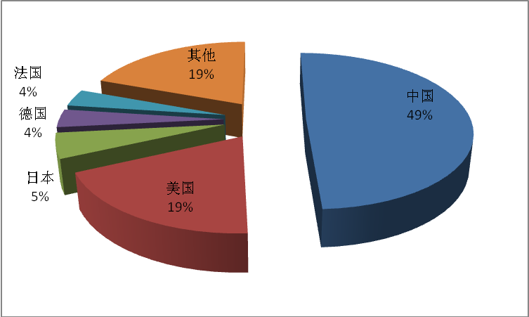

**(IV) Promote the cooperation with other enforcement agencies**

Although the IPR enforcement by Customs effectively curbs the infringement activities, the key point to prevent the infringement activities still lies in the source. Therefore, Customs value the cooperation with enforcement agencies in China like public security organs and administrations for industry and commerce and protect the IPR together with them through establishing a close enforcement cooperation mechanism. In order to strengthen the connection and cooperation between administrative enforcement by Customs and criminal law enforcement by public security organs, the GACC together with the Ministry of Public Security held “Seminar on Strengthening the Cooperation Between Customs and Public Security Organs on Criminal Enforcement Concerning the IPR” in October 2009 to study the unsolved problems in the enforcement cooperation between Customs and public security organs and proposed further improvement measures.

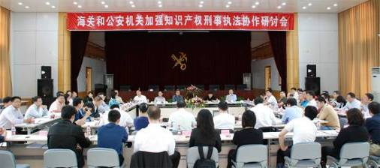

“Seminar on Strengthening the Cooperation Between Customs and Public Security Organs on Criminal Enforcement Concerning the IPR” held by the GACC and the Ministry of Public Security in October 2009

The Customs across the country, in accordance with the Interim Provisions on Strengthening Enforcement Cooperation Concerning the IPR (the “Interim Provisions”)of the Ministry of Public Security and the GACC, actively cooperate with the local public security organs, and report and transfer the suspected IPR infringement cases arising from customs supervision to the public security organs. Customs across the country, in accordance with the Interim Provisions*,* transferred 186 suspected IPR infringement cases to the public security organs in 2009.

In May 2009, the on-site export examination customs officers of Ningbo Customs, through risk analysis, successively seized more than 600,000 fake commodities like sport shoes, sport suit, DVD players, mobile phones, earphones, radios, watches, glasses, underwear, bags, clothes, silk scarves, belts, and batteries ready to be exported by a company in Shenzhen counterfeiting more than 60 international famous brands such as ADIDAS, JVC, NOKIA, NIKE, CASIO, Christian Dior, GIANNI VERSACE, LV, and ROLEX. Ningbo Customs immediately reported such issue to the local public security organ and explained the customs declaration procedures of foreign trade export to the public security organ and assisted the authorities of public security in preserving evidence and collecting customs declaration data against samples of commodities in question so as to help the public security organ smoothly conduct investigation work on such case.



Commodities counterfeiting more than 60 international famous brands seized by Ningbo Customs

**(V) Deepen the cooperation with the IPR holders and establish strategic partnership to protect the IPR**

It's also an important task for China Customs to deepen the cooperation with the IPR holders in 2009. The GACC has been maintaining a smooth contact and communication channel with foreign-invested enterprises and certain trade associations in China with respect to IPR protection. In 2009, the GACC held several seminars with the IPR holders with respect to customs legislation, study of enforcement issue and enforcement cooperation with foreign Customs, and obtained comments on customs work from enterprises. In order to promote the front line Customs officers’ IPR enforcement capacity, Customs of each port invited the IPR holders to supervise the training on identifying the infringement commodities on site more than 60 times. During the “special action for IPR protection in post and express delivery sections”, the GACC, in concert with Quality Brands Protection Committee (QBPC) of China Association of Enterprises with Foreign Investment (CAEFI), also held a training for the corresponding customs supervisors for postal delivery and express mails, which had a positive effect on the intended achievements of such special action.

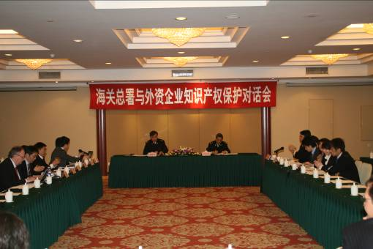

Dialogue on IPR protection between the GACC and foreign-funded enterprises in March 2009



“Seminar on Strengthening IPR Cooperation between Customs and Parties Concerned in the Industry” held by the GACC and the QBPC in August 2009

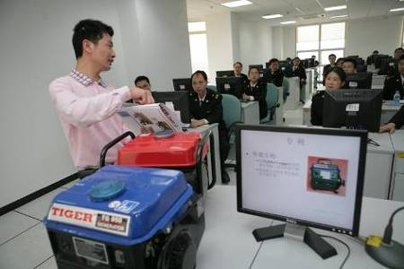

Fujian Customs invited representatives from Fujian Tiger Power Machine Co., Ltd. to introduce the particulars of infringing products to customs officers

**(VI) Further expand the IPR enforcement cooperation with international Customs**

In 2009, China Customs actively carried out international IPR enforcement cooperation. In August 2009, the Third Meeting of the Tripartite (China, Japan and the Republic of Korea) Customs Working Group on the IPR was held in Beijing, wherein the implementation of “IPR Protection Action Plan (fake zero project) of China, Japan and the Republic of Korea Customs” was reviewed and the improvement to the implementation work was studied. In January 2009, China and EU Customs signed the Action Plan on Enhancing IPR Protection Cooperation Between China and EU Customs (the “Action Plan”). Thereafter, Customs of China and EU held several negotiations over the Action Plan, formed a diagram for implementation of the Action Plan, set up a union working group and experts group and established a mechanism of cooperation; Customs of China and the U.S. continued to carry out highly effective cooperation in exchanging enforcement experience and statistics data on cases, notifying individual case information, and other aspects under relevant provisions of the Memorandum on Enhancing Enforcement Cooperation Concerning the IPR Between China Customs and U.S. Customs.

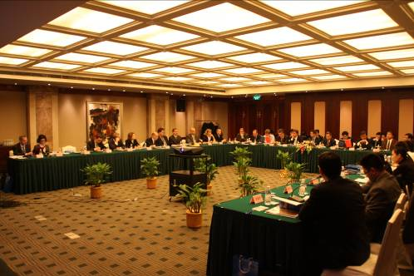

The First Meeting of Experts Group of Action Plan on the IPR Between China and EU Customswas held in Shanghai in November 2009

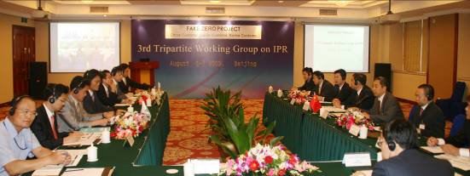

The Third Tripartite Working Group Meeting on IPR (“fake zero project”) was held in Beijing in August 2009

In addition, China Customs sent representatives to introduce the status of IPR protection of China Customs to various countries’ representatives through participating in a series of IPR-related international activities and to comprehensively communicate with representatives of other countries.

**(VII) Vigorously carry out publicity and education campaign on IPR for import & export enterprises and manufacturing enterprises**

During the “4.26” IPR Publicity Week in 2009, the GACC organized a series of publicity and education campaign for social public:

■ Organizing the 2009 “China High-Level Forum on IPR Protection” in concert with the State Intellectual Property Office (SIPO) and the Ministry of Public Security;

■ Issuing the White Paper on China Customs Intellectual Property Protection in 2008;

■ Appraising and selecting the top ten cases of customs IPR protection in 2008;

■ Organizing special dialogues on customs IPR protection with netizens on the China Customs Internet portals;

■ Cooperating with CCTV to shoot the series feature films of Discussing Laws by AnalyzingCases reflecting Customs IPR enforcement.



Vice Minister of Customs Li Kenong was making a speech on “China High-Level Forum on IPR Protection”



The Chief of Department of Policy and Legal Affairs of GACC Meng Yang was speaking glowingly of IPR with netizens on the GACC website

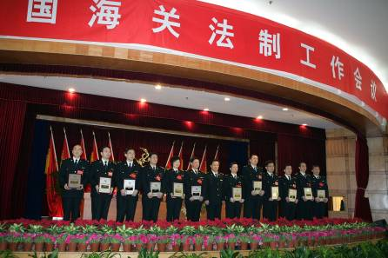

The award ceremony of “Top Ten Cases of Customs IPR Protection” held in April 2009

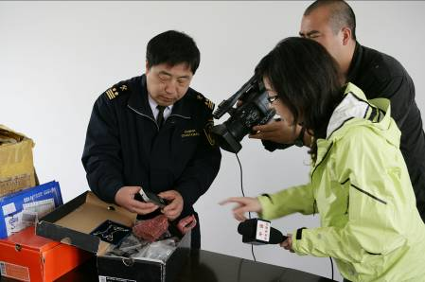

CCTV was shooting the feature films of enforcement in post and express delivery sections in Shanghai Customs

Local Customs also, in accordance with the requirements of GACC, strengthened IPR enforcement, and meanwhile, regarded the IPR publicity and education campaign for social public as a significant part of Customs IPR protection work. The publicity and education campaign by Customs has greatly raised the IPR protection awareness of domestic enterprises. After receiving overseas customers’ orders, many enterprises undertaking Original Equipment Manufacture initiatively asked Customs for help to confirm the status of IPR of the orders so as to avoid infringement caused by lack of knowledge which might cause economic losses to enterprises. Some enterprises, once exporting infringing goods, also were applying to Customs for their IPR protection because of raised IPR protection awareness. IPR publicity and education campaign for social public carried out by Customs played an active role in preventing infringement from source.

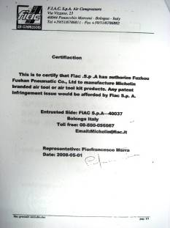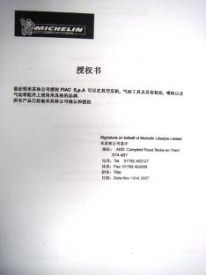

(Left) An order of commissioning to producing a batch of “Michelin” gas-charging tools by an Italian company, which was confirmed under Fuzhou Customs’ assistance at a Fuzhou company’s request; (Right) The Certificate of Authorization of Michelin’s permission to use its trademark provided by the Italian company (which is confirmed by Michelin as forge)

In a word, the achievements in IPR enforcement obtained by China Customs in 2009 were the result of insisting on the policy of “administration under law and check for the country” by the national Customs. The IPR protection work of China Customs is highly spoken by all sectors of society. In the internal questionnaire carried out by China Association of Enterprises with Foreign Investment (CAEFI) Quality Brands Protection Committee (QBPC) comprised of over 180 multinational corporations, China Customs were awarded again as one of the most efficient enforcement departments concerning the IPR. The chief inspector responsible for global IPR of Nokia Ms Lucy Nichols expressed her comments on IPR enforcement by China Customs that “China Customs is the best in IPR protection among all countries' customs around the world. China Customs has done their best in fighting against infringement, and now it is others’ turn to take actions.”[10]Many home and abroad enterprises also expressed their earnest expectations to continue with the development of IPR cooperation with China Customs in different occasions.

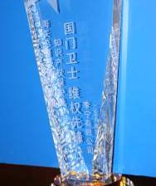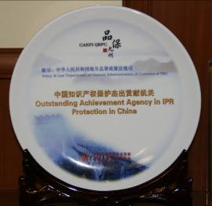

(Left) The medal of “Bodyguard of the Country’s Gate, Pioneer of Rights Protection” given by Li Ning Sporting Goods Corporation to GACC; (Right) The medal of “Outstanding Achievement Agency in IPR Protection in China” issued by QBPC to GACC

**IV. Key Work of Customs IPR Protection in 2010**

In 2010, China Customs will continue strengthening the IPR enforcement and stringently cracking down on the infringements and illegal activities for the import and export. Great attention will be paid to the following work by the GACC:

**(I) Enhance the collection of the infringement information and the analysis of the risk to improve the efficiency of Customs in tracking down on the infringing goods**

In 2010, China Customs will take measures to further simplify the customs formalities to facilitate the legal import and export. This requires that the risk analysis method be used much more by China Customs during the IPR enforcement to realize the “intelligentization” of the Customs IPR enforcement. Therefore, the GACC will request port customs to widely collect the entry-exit information on the infringing goods. In the process of the IPR enforcement, the skill of the risk analysis should be vigorously promoted, and the monitoring of the imported and exported infringing goods should be conducted pertinently in order to improve the seizure rate for the infringing goods despite of the limited goods inspection rate.

**(II) Develop the protection for the World Expo symbols and relevant IPR and create a favorable external environment for the organization of the Shanghai World Expo**

In May 2010, the 41st World Expo will be held in Shanghai, China. By the end of 2009, 57 World Expo symbols in total have been registered with the GACC. With the approaching of the Expo, illegal activities which infringe the exclusive right of the World Expo symbols and other IPR at import and export links will also be increased. China Customs will increase the protection of the IPR concerning the World Expo and strictly crack down on the relevant illegal activities according to the unified deployment of the GACC so as to create a favorable IPR environment for the successful organization of the Shanghai World Expo.



(Left picture) World Expo symbol “Haibao” registered with the GACC; (right picture) 50,000 toothbrushes to be exported which illegally used the World Expo symbol “Haibao” and were detained by Shanghai Customs in May 2009. This is the first batch of goods that have infringed the exclusive right of the World Expo symbols seized by China Customs.

**(III) Increase the protection and support of** **the proprietary IPR of domestic enterprises to make them fully benefit from the** **IPR protection by the Customs**

Although the domestic enterprises have significantly raised the awareness of the IPR protection and the ability of safeguarding rights, there are objectively great disparities compared with the international multinational enterprises. For this purpose, the Customs will increase the publicity and support efforts for the domestic enterprises with the proprietary IPR to protect their IPR, and help them solve the problems they encounter when they seek the protection from the Customs. The Customs will make positive contributions to the globalization and good reputation of Chinese brands on the international market.

**(IV) Reinforce IPR publicity and education for domestic OEM enterprises to try to eliminate more infringements from the source**

China is the largest export country in the world. However, the majority of export processing enterprises in China have a serious lack of IPR protection awareness. Some of them are unable to have an immediate examination on IPR conditions after receiving OEM orders from foreign merchants, and even need to be liable for legal consequences of infringements. Among 1,342 consignments of suspected infringing goods seized by Chinese Customs according to records in 2009, 323 consignments were expected to be exported by Chinese enterprises upon receiving OEM orders from foreign merchants, accounting for 24% of the total consignments. In order to eliminate export of infringing products from the source and to reduce economic losses suffered by Chinese enterprises due to acceptance of infringing orders, Chinese Customs will provide IPR publicity and education for Chinese OEM enterprises, which will be an important task in 2010.

**(V) Expand and deepen cooperation with other departments and form a resultant force for IPR protection**

It is well known that the key to crack down on infringement lies on the source. Thus, in the coming new year, the Customs will strengthen the cooperation with other IPR enforcement departments with respect to patent administration, copyright administration, drug surveillance and tobacco monopolization while further cracking down on criminal activities of import & export infringement with public security organs. In addition, the Customs will reinforce the cooperation with postal service departments. In 2009, Chinese Customs seized 45,000 consignments of infringing goods exported or imported by post in total, which increased by nearly 5 times, as compared with those of 2008. Along with the development of Internet and E-commerce, “order online and post delivery” gradually becomes an important mode for trade in infringing commodities. The enhancement of cooperation between Customs and postal service departments will effectively restrain lawless persons' intention to export or import infringing commodities by post.

**(VI) Strengthen communication and exchange with IPR holders and encourage enterprises to give more powerful support and assistance in the fight against infringement**

The IPR protection by the Customs requires IPR holders to give assistance and especially to provide information and support for the Customs to identify and affirm infringing goods, in which process IPR holders play an important role. Among the goods which were suspended to be released in freight transport by the Customs due to IPR protection in 2009, there were up to 1,322 consignments which were legally authorized goods as confirmed by IPR holders or which were finally released by the Customs due to IPR holders’ failure to apply to the Customs for detaining or otherwise, including 120 million commodities to be exported or imported. According to the provisions of the Regulations on Customs Protection of Intellectual Property Rights, when IPR holders apply to the GACC for IPR protection registration, they shall provide the information about the goods for which the IPR is legally executed and shall apply to the Customs for detaining goods within 3 working days upon receipt of a written notice showing that suspected infringing goods are suspended to be released by the Customs. IPR holders’ passivity and slackness may, to a large extent, render the delay for legal goods to be cleared by the Customs. Thus, in 2010, the GACC will take effective measures to encourage passivity right holders to more actively assist the Customs in IPR enforcement so as to facilitate the import and export of legal goods and maintain the legitimate rights and interests of exporting or importing merchants.

**(VII) Carry on enforcement cooperation with overseas Customs to crack down on international trade infringements**

The problem of infringing trade is worldwide, so it is necessary for each country’s enforcement organs, especially the Customs, to pull together to solve the problem. In 2010, Chinese Customs will cooperate with overseas Customs in the following activities regarding IPR enforcement:

■ carrying on the highly effective cooperation with U.S. Customs in exchanging enforcement experience and statistics data on cases, notifying individual case information, and other aspects under relevant provisions of the Memorandum on Enhancing Enforcement Cooperation Concerning the IPR Between China Customs and U.S. Customs;

■ carrying on the communication and exchange with EU Customs in statistical case information and case information of corresponding cases;

■ strengthening the cooperation with Russian Customs in cracking down on international trade in infringing goods;

■ carrying on the enforcement cooperation under the framework of IPR cooperation among China, Japan and Republic of Korea; and

■ perfecting the IPR enforcement cooperation system between the GACC and the Hong Kong Customs and Excise Department as infringing commodities are frequently traded between Mainland and the Hong Kong Special Administrative Region.

Appendix:

**Statistics of China Customs IPR Enforcement in 2009**

**Table 1 Statistics of Consignments of Goods Suspended** **to be Released and Detained in 2009**

|  |  |  |  |  |
| --- | --- | --- | --- | --- |
| **Year** | **Consignments Suspended to be Released** | **YoY Rate** | **Consignments Detained** | **YoY Rate** |
| 2008 | 13,140 |  | 11,135 |  |
| 2009 | 67,051 | 410.28% | 65,810 | 491% |

Unit of goods suspended to be released and detained: batch

**Table 2 Statistics of Infringing Goods Detained by the Customs in 2009**

|  |  |  |  |  |
| --- | --- | --- | --- | --- |
| **Year** | **Quantity of Infringing Goods** | **YoY Rate** | **Value** | **YoY Rate** |
| 2008 | 645,182,937 |  | 294,802,157 |  |
| 2009 | 280,058,800 | -56.59% | 452,334,298 | 53.43% |

Unit for the quantity of infringing goods: piece/pair; value unit: RMB

**Table 3 Statistics of Infringing Import & Export Goods Seized by the Customs in 2009**

|  |  |  |  |  |
| --- | --- | --- | --- | --- |
| **Import/Export** | **Quantity of Infringing Goods** | **Proportion** | **Value** | **Proportion** |
| Import | 103,558 | 0.1% | 4,245,587 | 1% |
| Export | 279,955,242 | 99.9% | 448,088,711 | 99% |

Unit for the quantity of infringing goods: piece/pair; value unit: RMB

**Table 4 Statistics of Infringing Goods Involved IP Types**

|  |  |  |  |  |  |
| --- | --- | --- | --- | --- | --- |
| **IP Type** | **Involved Consignments** | **Quantity of Goods** | **Proportion** | **Value** | **Proportion** |
| Exclusive Right to Use Trademark | 65,188 | 276,651,530 | 99% | 425,371,077 | 94% |
| Copyright | 5,810 | 131,747 | Less than 1% | 2,733,974 | Less than 1% |
| Patent | 102 | 3,237,699 | Less than 1% | 24,081,373 | 5% |
| Olympic Symbol/ World Expo Symbol | 5 | 37,824 | Less than 1% | 147,873 | Less than 1% |

Batch unit: batch; unit of goods: piece/pair; value: RMB

**Figure 5 Statistics of Quantity and Value of Infringing Goods Detained by Customs in 2009**

|  |  |  |  |  |
| --- | --- | --- | --- | --- |
| **Goods Category** | **Quantity of Goods** | **Proportion** | **Value** | **Proportion** |
| Tobacco | 181,346,116 | 1.80% | 31,237,651 | 6.90% |
| Others | 46,761,330 | 0.40% | 25,807,920 | 5.70% |
| Other Light Industrial Products | 15,918,160 | 0.10% | 1,959,904 | 0.40% |
| Cosmetics and Care Products | 10,996,937 | 0.20% | 10,757,195 | 2.40% |
| Hardware and Machinery | 8,712,423 | 3.90% | 30,503,080 | 6.70% |
| Clothing | 4,986,126 | 5.70% | 44,083,239 | 9.80% |
| Medicine | 3,344,790 | 0.60% | 8,555,921 | 1.90% |
| Other Mechanical and Electrical Products | 1,747,306 | 0.10% | 42,909,738 | 9.50% |
| Autos and Motorcycles | 1,580,608 | 0.10% | 2,893,802 | 0.60% |
| Communication Devices | 1,469,595 | 0.50% | 57,628,798 | 12.70% |
| Shoes | 1,184,250 | 0.03% | 7,894,969 | 1.80% |
| Bags and Leatherware | 418,746 | 0.60% | 21,765,950 | 4.80% |
| Watches | 319,770 | 3.10% | 10,226,569 | 2.30% |
| Toys and Games | 313,311 | 0.01% | 4,101,115 | 0.90% |
| Caps and Hats | 282,262 | 0.05% | 793,251 | 0.04% |
| Food and Drink | 212,533 | 0.07% | 199,920 | 0.04% |
| Medial Equipment | 198,744 | 1.20% | 48,379,124 | 10.70% |
| Gymnastic Apparatus | 130,893 | 0.10% | 846,142 | 0.20% |
| Storage Medium | 95,735 | 64.80% | 57,874,722 | 0.20% |
| Jewelry | 39,165 | 16.70% | 43,915,285 | 9.70% |

Unit for the quantity of goods: piece/pair; value unit: RMB

**Table 6 Statistics of Categories of Infringing Goods Detained by the Customs in 2009 and 2008**

|  |  |  |  |  |  |  |
| --- | --- | --- | --- | --- | --- | --- |
|  | **Quantity of Goods** | | | **Value of Goods** | | |
| **Goods Category** | **2009** | **2008** | **YoY Rate** | **2009** | **2008** | **YoY Rate** |
| Clothing | 4,986,126 | 1,613,877 | 209% | 31,237,653 | 22,276,084 | 40.23% |
| Shoes | 1,184,250 | 888,685 | 33.10% | 25,807,920 | 17,145,646 | 50.52% |
| Caps and Hats | 282,262 | 331,962 | -15% | 1,959,904 | 4,072,076 | -52% |
| Bags and Leatherware | 418,746 | 380,710 | 10% | 10,757,195 | 6,100,531 | 76.33% |
| Cosmetics and Care Products | 10,996,937 | 5,505,752 | 100% | 30,503,080 | 21,200,760 | 43.88% |
| Other Light Industrial Products | 15,918,160 | 27,359,492 | 42% | 44,083,239 | 28,786,062 | 53.14% |
| Autos and Motorcycles | 1,580,608 | 998,389 | 58% | 8,555,921 | 11,737,826 | -27% |
| Watches | 319,770 | 225,948 | 42% | 42,909,738 | 4,867,393 | 781.58% |
| Toys and Games | 313,311 | 374,100 | -16% | 2,893,802 | 2,243,334 | 29.00% |
| Communication Devices | 1,469,595 | 1,093,602 | 34% | 57,628,798 | 22,775,068 | 153.03% |
| Storage Medium | 95,735 | 456,192 | -79% | 7,894,969 | 6,832,480 | 15.55% |
| Other Mechanical and Electrical Products | 1,747,306 | 3,800,796 | -54% | 21,765,950 | 16,398,522 | 32.73% |
| Hardware and Machinery | 8,712,423 | 1,136,291 | 667% | 10,226,569 | 9,258,069 | 10.46% |
| Jewelry | 39,165 | 94,165 | -58% | 4,101,115 | 1,019,940 | 302.09% |
| Gymnastic Apparatus | 130,893 | 148,630 | -12% | 793,251 | 1,628,809 | -51% |
| Medial Equipment | 198,744 | 0 |  | 199,920 | 0 |  |
| Medicine | 3,344,790 | 230,762 | 1349% | 48,379,124 | 7,247,302 | 567.55% |
| Food and Drink | 212,533 | 1,563,553 | -86% | 846,142 | 1,910,929 | -56% |
| Tobacco | 181,346,116 | 562,765,960 | -68% | 57,874,722 | 83,726,791 | -31% |
| Others | 46,761,330 | 36,214,071 | 29% | 43,915,284.67 | 25,574,535 | 71.71% |

Unit for the quantity of goods: piece/pair; value unit: RMB

**Table 7 Mode of Transport for Infringing Goods (by Detained Consignments)**

|  |  |  |  |  |  |  |  |
| --- | --- | --- | --- | --- | --- | --- | --- |
| **Mode of Transport** | **By Post** | **By Express Delivery** | **By Sea** | **By Air** | **By Truck** | **By Train** | **Others** |
| Consignments | 44,584 | 18,262 | 1,490 | 316 | 501 | 149 | 508 |
| Proportion | 68% | 28% | 2% | 0.5% | 0.8% | 0.2% | 0.8% |
| YoY Rate | 500% | 1,162% | 31% | -8% | 171% | 19% | 9% |

Batch unit: batch; “Others”: passenger carriage; bonded zone, bonded warehouse, etc.

**Table 8 Mode of Transport for Infringing Goods (by Quantity of Goods)**

|  |  |  |  |  |  |  |  |
| --- | --- | --- | --- | --- | --- | --- | --- |
| **Mode of Transport** | **By Post** | **By Express Delivery** | **By Sea** | **By Air** | **By Truck** | **By Train** | **Others** |
| Quantity of Goods | 2,690,886 | 1,003,927 | 273,783,586 | 137,524 | 2,080,851 | 144,366 | 217,660 |
| Proportion | 1% | 0.4% | 98% | 0.1% | 0.7% | 0.1% | 0.1% |
| YoY Rate | -2% | -28% | -57% | -68% | -69% | 2% | 79% |

Unit for the quantity of goods: piece/pair; “Others”: passenger carriage; bonded zone, bonded warehouse, etc.

**Table 9 Mode of Transport for Infringing Goods (by Value)**

|  |  |  |  |  |  |  |  |
| --- | --- | --- | --- | --- | --- | --- | --- |
| **Mode of Transport** | **By Post** | **By Express Delivery** | **By Sea** | **By Air** | **By Truck** | **By Train** | **Others** |
| Value | 91,292,878 | 16,788,386 | 289,517,294 | 36,778,820 | 12,608,093 | 2,191,014 | 3,157,813 |
| Proportion | 20% | 4% | 64% | 8% | 3% | 1% | 1% |
| YoY Rate | 330% | 246% | 19% | 172% | 82% | -19% | 33% |

Value unit: RMB; “Others”: passenger carriage; bonded zone, bonded warehouse, etc.

**Table 10 Statistics of Infringing Goods Detained by Each Customs District Directly under the GACC**

|  |  |  |  |
| --- | --- | --- | --- |
| **Customs District Directly under the GACC** | **Consignments** | **Quantity of Goods** | **Value** |
| Beijing Customs | 3,541 | 188,839 | 87,785,500 |
| Tianjin Customs | 195 | 507,146 | 3,533,341 |
| Hohhot Customs | 5 | 1,108 | 70,710 |
| Manzhouli Customs | 3 | 2,040 | 20,371 |
| Dalian Customs | 136 | 84,902 | 4,845,695 |
| Shenyang Customs | 72 | 18,399 | 206,055 |
| Changchun Customs | 5 | 52,877 | 75,468 |
| Harbin Customs | 1,648 | 13,202 | 1,975,472 |
| Shanghai Customs | 35,739 | 8,172,781 | 57,782,936 |
| Nanjing Customs | 156 | 48,867 | 2,739,753 |
| Hangzhou Customs | 3,655 | 15,735,158 | 36,293,624 |
| Ningbo Customs | 301 | 29,771,703 | 36,052,220 |
| Hefei Customs | 3 | 3,170 | 130,758 |
| Fuzhou Customs | 235 | 446,095 | 6,475,732 |
| Xiamen Customs | 186 | 1,861,626 | 9,025,824 |
| Qingdao Customs | 488 | 924,174 | 7,782,302 |
| Zhengzhou Customs | 10 | 351 | 9,600 |
| Wuhan Customs | 369 | 23,958 | 2,095,896 |
| Changsha Customs | 74 | 45,947 | 1,625,343 |
| Guangzhou Customs | 12,859 | 423,465 | 7,808,199 |
| Shenzhen Customs | 4,702 | 203,243,082 | 157,421,868 |
| Gongbei Customs | 759 | 315,356 | 9,493,030 |
| Shantou Customs | 9 | 23 | 2,300 |
| Huangpu Customs | 75 | 17,655,758 | 11,274,623 |
| Jiangmen Customs | 14 | 41,692 | 617,800 |
| Zhanjiang Customs | 2 | 28,248 | 1,300,422 |
| Nanning Customs | 70 | 66,837 | 2,266,538 |
| Haikou Customs | 1 | 12 | 12,000 |
| Chongqing Customs | 47 | 10,769 | 120,555 |
| Chengdu Customs | 46 | 353 | 217,900 |
| Kunming Customs | 130 | 20,516 | 219,396 |
| Lhasa Customs | 32 | 12,419 | 269,620 |
| Xi’an Customs | 182 | 78,525 | 1,233,740 |
| Urumqi Customs | 61 | 259,402 | 1,549,707 |

Batch unit: batch; unit of goods: piece/pair; value: RMB

**Table 11 Enforcement Mode for Infringing Goods Detained by the Customs in 2009**

|  |  |  |  |  |  |  |
| --- | --- | --- | --- | --- | --- | --- |
| **Enforcement Mode** | **Consignments** | **Proportion** | **Quantity of Goods** | **Proportion** | **Value** | **Proportion** |
| Detained upon Application | 111 | 0.2% | 4,119,650 | 1.5% | 26,002,787 | 5.7% |
| Detained upon Registration | 1,342 | 2% | 271,825,399 | 97% | 273,897,717 | 60.6% |
| Luggage and Postal Parcel Cases | 64,365 | 97.8% | 4,113,751 | 1.5% | 152,433,793 | 33.7% |

Batch unit: batch; unit for the quantity of goods: piece/pair; value: RMB

**Table 12 Statistics of Special Action for Post and Express Delivery Sections**

|  |  |  |  |
| --- | --- | --- | --- |
| **Item** | **Special Action (June – December 2009)** | **June – December 2008** | **YoY Rate** |
| Consignments | 37,914 | 4,523 | 738% |
| Quantity of Goods | 2,612,891 | 2,044,560 | 28% |
| Value | 61,662,735 | 12,266,000 | 402% |

Batch unit: batch; unit for the quantity of goods: piece/pair; value: RMB

1. As provided in the Regulations of the People’s Republic of China on Customs Protection of Intellectual Property Rights, for any imported and exported goods that are suspected of infringing any intellectual property right registered in the GACC, the Customs can suspend the release of such goods and notify the intellectual property rights holder in writing. In case the intellectual property rights holder requires detention of the suspected infringing goods, it shall apply to the Customs within 3 working days after receipt of the written notice from Customs and give security. Where the intellectual property rights holder fails to make an application or give security, the Customs shall release the goods in question.
2. Both “infringing goods” and “infringing commodities” refer to the goods detained by Customs for being suspected of infringement, including those determined not constituting infringement after Customs survey or judgment by a people’s court, those that the Customs fail to determine whether they are involved in infringement or not or those released from detention by Customs upon settlement agreement of parties concerned.
3. As the packaging specifications of cigarettes are different from country to country, international statistics about imported and exported cigarettes detained by Customs are mostly made by “piece” as the unit, i.e. “a piece of cigarette is an article of commodity”. China Customs also make statistics in such way; therefore, the value of each piece of tobacco is relatively lower than that of other commodities.
4. As provided in Article 51 of TRIPS, the contracting parties can only prepare procedures enabling right holders to submit written request to appropriate judicial or administrative authorities for suspending by Customs the release of the imported goods into free flow. For infringing goods prepared to be exported from their territory, the contracting parties may also, but not be obliged to, make procedure for Customs’ suspension of release.
5. The same batch of infringing goods detained by Customs may contain commodities infringing valorous intellectual property rights; therefore, the sum of consignments of infringing goods involving various types of intellectual property rights is larger than the sum of consignments of infringing goods detained by Customs.
6. The articles transported by mail are characterized by large number of consignments, but low quantity and high value of commodities; while the shipping goods are characterized by small number of consignments and relative low value.
7. “Items” of IPR here refer to the times that the infringing goods detained by Customs are related to intellectual property.
8. “China” herein excludes Hong Kong, Macao and Taiwan of China.
9. See Article 51 of TRIPS Agreement
10. The speech on “GACC-Industry IPR Protection Dialogue” on March 26, 2010