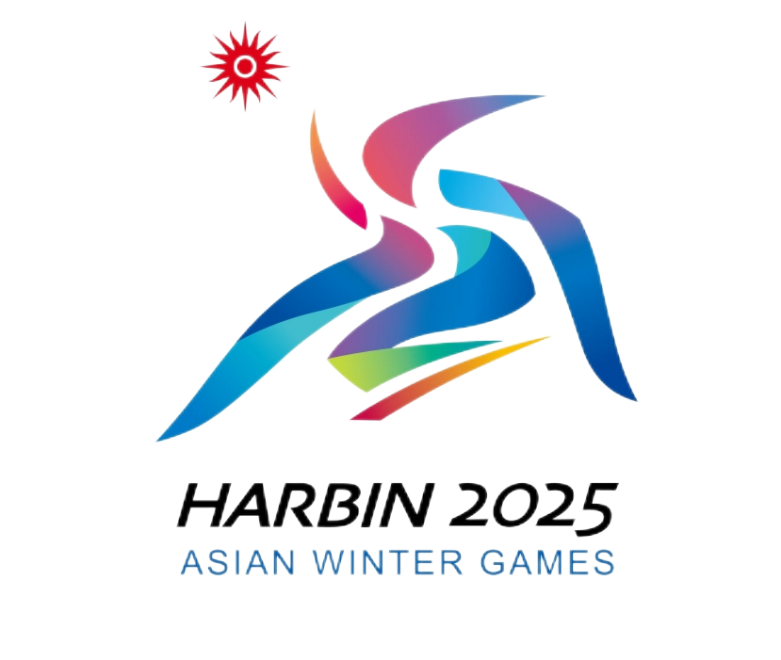
Annex 1
Letter of Evidence for Imported Goods for Harbin 2025
2025年第九届亚洲冬季运动会进境物资证明函

（ ） Customs海关
Letter of Evidence No.: 证明函编号：
Certified by:证明人：
List of Imported Goods No.:物资清单编号：
Country/Region  国别 |  | Means of Transport  运输工具 |  |  |  |  |  | Import Date  进境日期
Bill of Lading (Waybill)  提（运）单号 |  |  |  |  |  |  |  | Weight (kg)  重量(Kg)
Description货物名称 |  |  |  |  |  |  |  | Quantity数量
Consignee and Consigner  收发货人 |  |  |  |  |  |  |  | Ten-digit Code  十位编码
Customs Broker  代理报关机构 |  |  |  |  |  |  |  | Ten-digit Code  十位编码
 | Contact Person: 联系人： Contact Info:联系方式：
Supervision Mode  监管方式 | □Temporary Import  暂时进境 |  | □Duty-free Import  免税进境 |  | □Formal Import  正式进口 |  | □Leased Goods  租赁货运 |  | □Exhibits  展览  品 | □Customs Transit  转关 | □Others  其他
Letter of Guarantee No.  保函编号 |  |  |  | Value (RMB)  货值（人民币）
Consumer
消费使用单位
Remarks备注
Certification:
证明事项：This is to certify that the goods are used for Harbin 2025 and are limited to the supplies imported during the Games. The 9th Asian Winter Games Harbin 2025 Organising Committee (HAWGOC) is committed to going through relevant formalities without delay according to the regulations of China Customs.兹证明此票货物为2025年第九届亚洲冬季运动会物资，仅用于2025年第九届亚洲冬季运动会物资进境。2025年第九届亚洲冬季运动会组委会保证按海关规定及时办理有关手续。

Handled by: (signature and seal)经办人：（签印）

Certified by: (official stamp) 证明人：（公章） Date: dd/mm/yyyy（日/月/年）
Contact Person: 联系人： |  |  |  |  |  | Tel:联系电话：
Records of Competent Customs:主管海关备案：
Remarks of Customs at the Place of Entry:进境地海关批注：
(Original: kept by the Customs at the place of entry; Copy 1: kept by competent Customs; Copy 2: kept by the certifier; Copy 3: submitted to the Customs at the place of exit.)
（正本：进境地海关留存 副本1：主管海关留存 副本2：证明人留存 副本3：复运出境时交出境地海关。）

